TEAM 3 - Strategic Carrier Model Simulation (SCMS)

03 March 2021

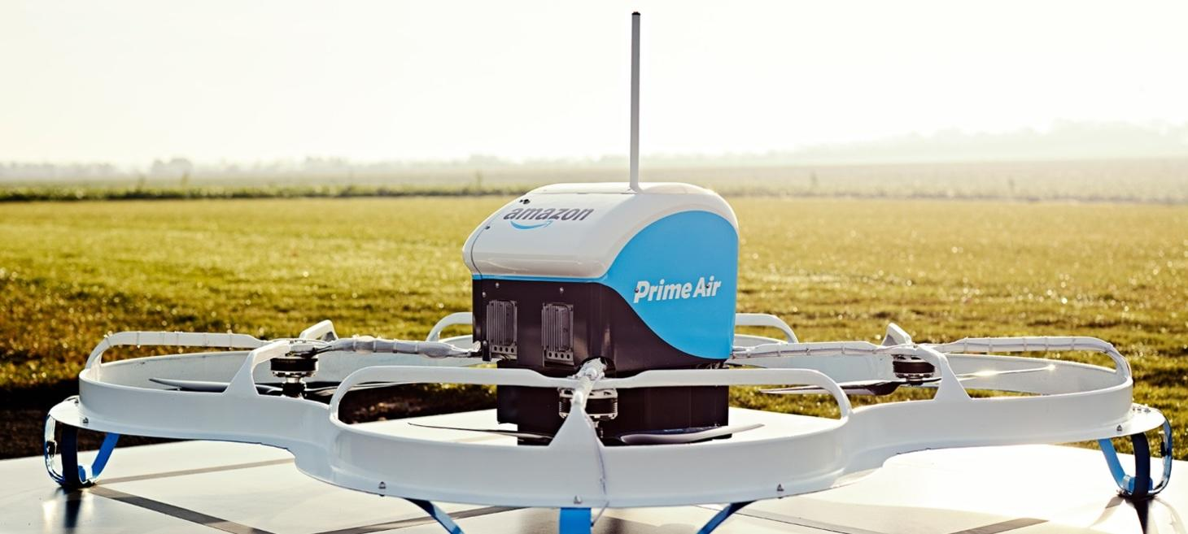

***Data Collection***

***Project Manager, Verification and Validation***

Tyler Hildebrandt

***Team Lead, Simulation***

***Requirements***

***Modeling***

Table of Contents

Table of Figures 4

Table of Tables 4

Executive Summary 5

Problem Statement 6

Background 6

Problem 7

Objectives 7

CONOPs and Systems Engineering Lifecycle 8

SE Lifecycle 8

Qualification for Prime Air 8

Flight Concept of Operations 9

MK27 UAS Drone 10

Conceptual model 11

Simulation Requirements 12

Model Assumptions 12

Model Simplifications 13

Order Distribution 13

Architectural views 15

System Theoretic Views 16

Data Collection 17

Population and Location 17

Verification & Validation 18

Verification & Validation Plan 18

Model Validation 19

Model Verification 21

Simulation Implementation 22

Optimization 22

Simulation Model/Simulation Program 23

Order Location 23

Customer Order Logic 24

Drone and Order Process Flow 25

Result Validation 26

Presentation 28

Experiments 30

Experiment 1, Varied Adoption Rate 30

Experiment 2, Varied On-time Percentage 31

Experiment 3, Varied Delivery Window 33

Results and Conclusions 35

Recommendations 35

Future Experiments 35

References 37

# Table of Figures

Figure 1: Drone fulfillment center patent 6

Figure 2: Baltimore drone service area 7

Figure 3: Systems Engineering Lifecycle 8

Figure 4: Amazon Air CONOPs 9

Figure 5: MK27 drone layout 10

Figure 6: SCMS conceptual model 11

Figure 7: Orders throughout the day (Baltimore service area) 14

Figure 8: SCMS completed conceptual model 15

Figure 9: SCMS activity diagram 16

Figure 10: Baltimore area census tracts 17

Figure 11: SCMS Intrinsic Verification & Validation flow 18

Figure 12: AnyLogic simulation optimization 22

Figure 13: Order agent 24

Figure 14: Customer state chart 25

Figure 15: Resource Flow Chart 26

Figure 16: Primary Experiment Run 27

Figure 17: Overload Scenario Run 27

Figure 18: Simulation data inputs 28

Figure 19: Simulation run 29

Figure 20: Adoption rate vs. number of drones (graph) 31

Figure 21: Number of drones vs. on-time percentage (graph) 32

Figure 22: Simulation run for 955 drones 32

Figure 23: Delivery window vs. number of drones (graph) 33

# Table of Tables

Table 1: MK27 drone specifications 10

Table 2: SCMS Requirements 12

Table 4: Requirement validation 19

Table 5: Order assumptions 20

Table 6: Drone delivery assumptions 20

Table 7: Tract Data Example 23

Table 8: Probability Table 24

Table 9: Adoption rate vs. number of drones 30

Table 10: Number of drones vs. on-time percentage 31

Table 11: Delivery window vs. number of drones 33

# Executive Summary

The strategic carrier modeling simulation (SCMS) was developed to identify behavioral characteristics of a drone delivery system applied to a city for the purpose of fleet sizing. It was found that the rate of adoption of drone delivery was a larger driver for fleet size than changing delivery time or delivery on-time percentage. Peak delivery rate was the main factor in sizing drone fleets but sizing for peak delivery times resulted in many drones being idle during off-peak hours. When changing the delivery window, fleet size was able to be dropped while still delivering all packages. This meant that a greater proportion of the delivery fleet was utilized throughout the day, but each individual drone would have increased use which could lead to greater maintenance costs.

For the purposes of our study the city of Baltimore, Maryland was chosen with the BWI2 Amazon Fulfillment Center (located at 2010 Broening Hwy) being used as the staging and launching location for the drones. A service area of 7.5 nautical miles around the fulfillment center and a 30-minute delivery window were used for the study referencing the Amazon Air CONOPs from the letter to the FAA seeking approval for drone use in delivery [1].

As part of the intrinsic verification and validation process for the development and acceptance of SCMS, a literature review was completed to identify similar studies. A conceptual model was built to determine the required fleet size building off a previous study done for the Chattanooga area [2]. The conceptual model was then broken down and cross referenced with the requirements from simulation, leading to the generation of the coded simulation.

Data was collected on the population within the service area, leveraging census data to determine the population within the 7.5 nautical mile service area, along with their location. For simplification only, census tracts were used to represent the population, with 225 tracts existing in the service area. Drone data was pulled from the Amazon Air CONOPs from their letter to the FAA [1] which was used to determine the key flight parameters needed to travel in the service area.

SCMS was coded in AnyLogic to make use of the local optimization function in the program. As part of the verification step, overload scenarios were used to find inconsistent behavior in the simulation that was then modified to match the conceptual model.

SCMS was then run for parameter variation in three experiments which have already been summarized. From those results future experiments were proposed, both using SCMS and utilizing real world equipment to increase the fidelity of SCMS by generating more representative time standards for delivery.

# Problem Statement

## Background

Amazon has transformed from an online book retailer to one of the largest commerce companies on the planet. The pivot from books to everyday retail services came as Amazon introduced their prime delivery service with two-day shipping on orders in the continental US in 2005. Amazon further improved on their delivery service in 2014 by introducing one day shipping on orders in select cities but expanded that service throughout the continental US.

As Amazon has grown, they have remained focused on shipping speed and delivery. Amazon has heavily invested in their own package delivery service, which as of 2019 delivered 12.8% of packages in the US, making Amazon the 4th largest US delivery service [3]. To reach that capability Amazon has invested heavily in the development of their delivery services to the tune of $39 Billion since 2014 [3]. This has enabled the continued growth of Amazon since their introduction of prime delivery but shipping costs have increased along with growth. It is estimated that Amazon will have a shipping cost of $117 Billion in 2025, growing from $38 Billion in 2019 [3].

Amazon is seeking to not only improve on their traditional package delivery capabilities, but future capabilities. Shown in Figure 1 below, is a patent for a fulfillment center for unmanned aerial vehicles (UAV) and is part of the extensive effort in UAV delivery system development.

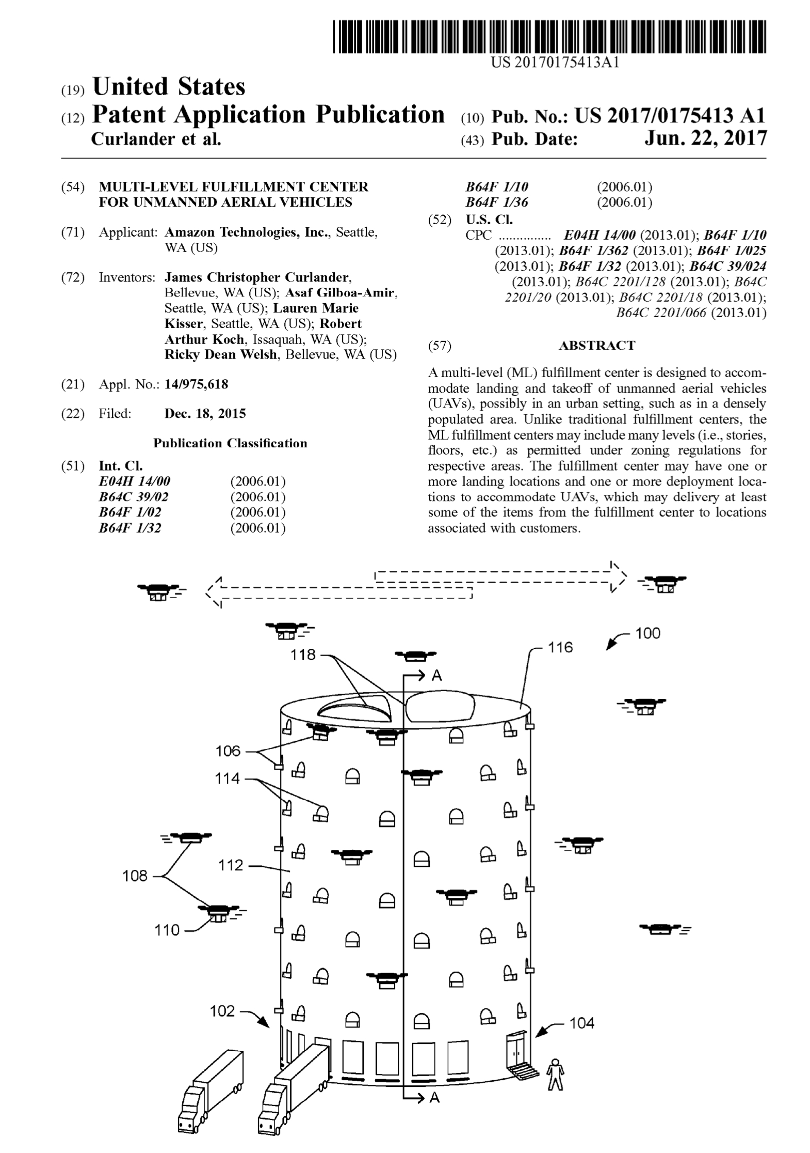

Figure 1: Drone fulfillment center patent

As stated in a letter to the FAA seeking an exemption to use unmanned aircraft systems (UAS) as part of the development of their Prime Air service [1]. Use of UAS to deliver packages within 30 minutes of ordering is seen as the next step in prime deliver breakthroughs that began with two-day shipping in 2005.

The feasibility of drone delivery from a financial standpoint is the subject of many papers and research. One study done considering Chattanooga, TN determined that there was not only an increase in convenience but in cost. According to said study, each traditional delivery would cost an estimated $1.20 per package, when considering only labor [2]. Conversely the cost of delivery with a drone, again considering only labor, would amount to $0.36 per package [2].

What this amounts to as Amazon marches toward drone delivery, is the need for effective means for determining drone fleet sizes to meet customer needs. Additionally, as Amazon moves toward drone delivery, as the fourth largest delivery service in the US, the market will increasingly turn toward drone delivery. Thus, a simulation to determine fleet size based on location and population density will be needed as not only Amazon but other delivery services begin to develop their own capabilities.

### Problem

The rise in e-commerce over the last decade has led to shifts in behaviors and spending. From that there has been a growing emphasis on reducing delivery time for orders as well as cost. Drone delivery is in its infancy but is a viable option to increase consumer convenience and reduce shipping cost. Due to the novelty of drone delivery, the application of a UAS delivery system is yet only studied through simplified models that have been done only using “back of the envelope” calculations such as those done by Sudbury and Hutchinson [2].

To determine the feasibility of drone delivery in American cities, a model and simulation must be developed to identify the impact of drone fleet size on package delivery. Simulation will focus on Baltimore metropolitan area with orders being fulfilled at the BWI2 Amazon Fulfilment Center shown in Figure 2 below.

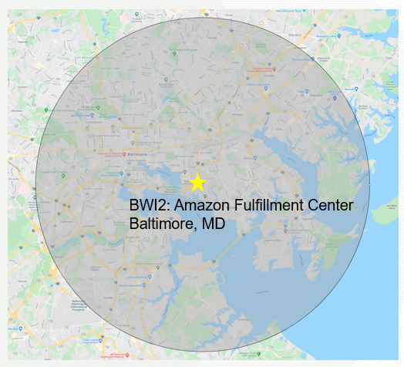

Figure 2: Baltimore drone service area

* Service Area is 7.5 NM radius
* Area includes:
  + Baltimore city
  + Baltimore County
  + Anne Arundel County

### Objectives

The objective is to determine the minimum number of MK27 drones required to achieve a 95 % on-time delivery rate within a 7.5 nautical mile radius of a Baltimore Amazon Fulfillment Center.

# CONOPs and Systems Engineering Lifecycle

## SE Lifecycle

Figure 3 shows the systems engineering lifecycle with the red ovals show where SCMS falls along this lifecycle. During the concept exploration phase, SCMS will evaluate need, environment, internet order times, assumptions, and limitations. During the system verification and deployment phase, SCMS will verify and validate that the drone delivery model is performing as expected given a specific scenario and set of assumptions. It will also validate it is meeting requirements. From the output of the model SCMS will verify the number of drones needed to deliver packages within a specific radius. In the future with more data, this model could be used to predict outcomes in other cities and inform delivery time confidence.

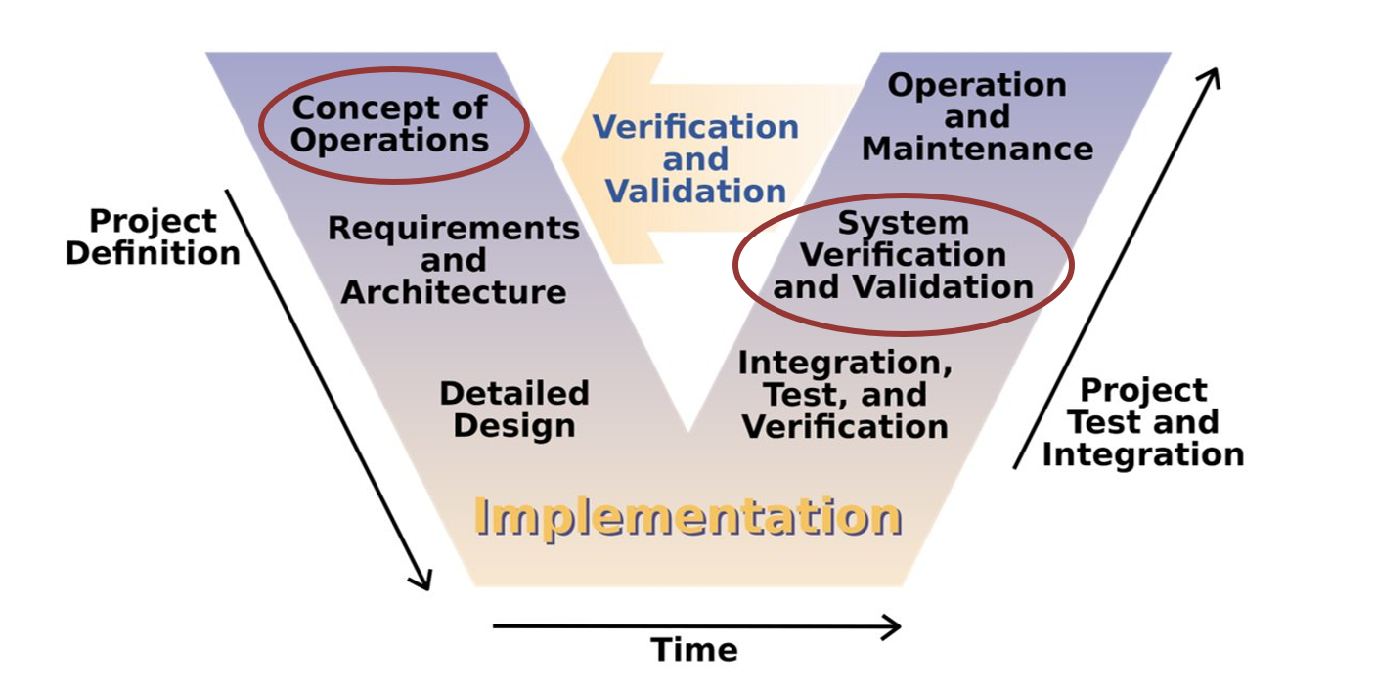

Figure 3: Systems Engineering Lifecycle

## Qualification for Prime Air

Prime Air will deliver packages using UAS to customers within 30 minutes of placing their order. Before a customer can place an order for delivery via Prime Air:

* Reviewed weather conditions to ensure the UA will remain within operational limits.
  + Icing: No flights in known icing conditions
  + Wind: Max 24 knots (total including gusts)
  + Areas of significant meteorological activity: No operations
* Identified all known airspace constraints.
* High level of confidence that the potential order can meet the 30-minute delivery commitment.
* Payload fits within the weight and space constraints of the MK27.

Only when all the conditions have been met, will the customer be offered the choice to select the Prime Air as a delivery option. This helps ensure the safe operations of the UAS to deliver the payload.

## Flight Concept of Operations

In the first phase, the pre-flight phase, an order is placed and a pre-flight inspection in completed to ensure that the done is in an airworthy state. The package is then prepared for delivery, including confirmation of accurate package weight. An Operator in Command (OIC) is then assigned to the drone through the duration of the mission. The OIC is also responsible for uploading mission data and authorizing launch.

After launch takes place from the amazon facility, the drone will be enroute to its destination. From the point of launch, the flight will be conducted autonomously. Separation assurance from other aircraft will be maintained through multiple layers of technical and operation safety mitigations. The flight path will be planned to avoid any known obstacles, and active onboard sensors will provide separation assurance from uncharted obstacles. Real time UA identification and tracking capabilities will also be available to the FAA facility that oversees local flight operations.

Once the UA arrives close to the delivery location, it will identify the specific delivery area through a unique marker and then perform a delivery area clear assessment using its onboard sensors. Once that condition has been met, the UA will descent to a delivery heigh that is safe. It will then hold in a hover position and release the package if there is no obstructions or hazards being sensed.

Once the delivery has been completed the UA will return to the Amazon facility. From there it will either stay at the facility, recharge, or go back into the pre-flight phase. Recharging will include swapping out the current battery pack in the UA with a different completely charged battery pack.

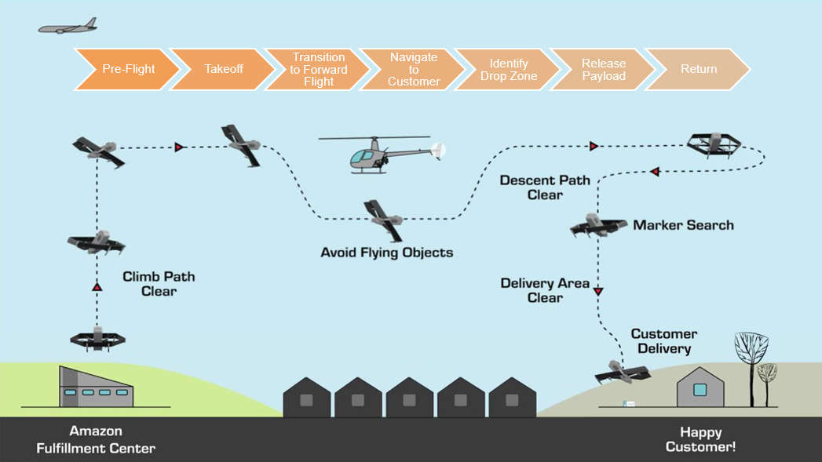

Figure 4: Amazon Air CONOPs

## MK27 UAS Drone

The MK27 drone is built by Amazon, shown below in Figure 5. It has a vertical lift and takeoff capability and is built to fly with increased efficiency, while being of a size that can carry a 5-lb package.

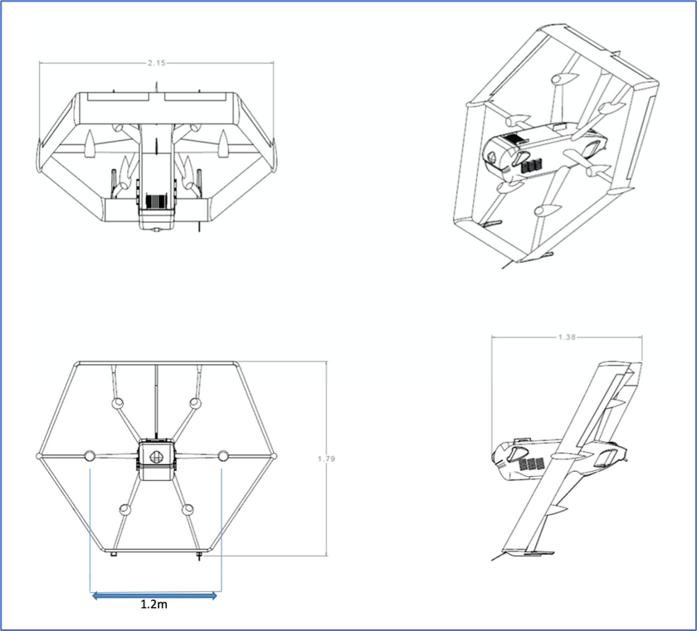

Figure 5: MK27 drone layout

MK27 will weight approximately 88 lbs, including carrying a payload of 5 lbs. MK27 will have a cruising speed of 60 knots, however the drone will not take off if winds read above 24 knots or under icing conditions. MK27 plans to fly at 400 ft max, although the drone can reach three times that height if need be. The MK27 is designed to perform automated response maneuvers to ensure separation from other objects so a safe landing can occur without operator intervention. This drone carries multiple sensors that allow it to maintain safe distances from unplanned obsticales without hitting power lines, obstacles or without posing any danger. MK27 hardware has gone through 15,000 simulated tests and the software has gone through 250,000 simulated tests. The FAA has already granted Amazon a certificate that will allow them to operate the drone for research and development, and crew training in authorized flight areas. Full specifications and characeristics for the MK27 drone are listed in Table 1 below.

Table 1: MK27 drone specifications

|  |  |
| --- | --- |
| **General Specifications & Performance Characteristics** | |
| UA Type | VTOL hybrid |
| Max payload weight at planned range | 5 lbs. |
| Nominal cruise speed | 60 kts. IAS |
| Max planned operating altitude | 400 ft. AGL |
| Max operating altitude | 1,200 ft AGL |
| Planned Range | 15 NM. Round trip (with reserve) |

# Conceptual model

The preliminary conceptual model is shown below in Figure 6 and describes a high-level overview of the model and simulation required for SCMS. It includes inputs required, assumed values and outputs generated via the model.

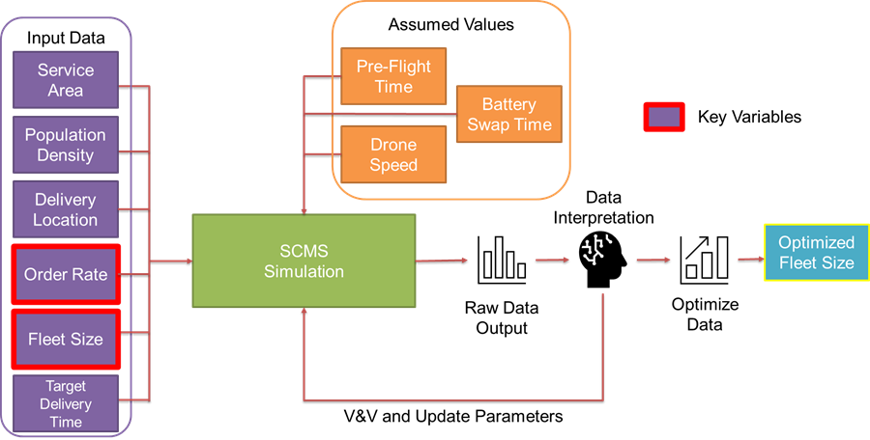

Figure 6: SCMS conceptual model

The inputs include:

* Service Area: 7.5 NM centered around the Baltimore metropolitan area.
* Population density data taken from the 2010 Maryland Census.
* Delivery Location specified through Tract locations.
* Order Rate: Number of incoming orders.
* Delivery Time: The max delivery time is constrained to 30 minutes.

The assumed values include:

* Pre-Flight Time: This will be a constant assumed value.
* Drone speed: This will be a constant known value.
* Recharge/Refuel time: This will be a constant assumed value.

The model generated output will be raw data on delivery time and on-time percentages. This data will then be interpreted and optimized to give the optimal number of drones according to deliver packages on-time 95% of the time.

## Simulation Requirements

Throughout the model development phase, the SCMS requirements were referenced to ensure model compliance. As the model and simulation were developed, as part of the intrinsic V&V plan the model was compared to the requirements to ensure model completeness.

The final requirements for SCMS are listed below.

Table 2: SCMS Requirements

|  |  |  |  |  |
| --- | --- | --- | --- | --- |
| Requirement ID​ | Requirement​ | Baseline​ | Input​ | Output​ |
| SCMS-001​ | The simulation shall generate the optimal number of drones needed to satisfy a service area around the Baltimore Amazon fulfillment center.​ | X​ | ​ | X​ |
| SCMS-002​ | The simulation shall consider various drone fleet sizes.​ | X​ | X​ | ​ |
| SCMS-003​ | The simulation shall provide delivery times from order confirmation to package delivery as an output.​ | X​ | ​ | X​ |
| SCMS-004​ | The simulation shall accept various order rates as an input. | X​ | X​ | ​ |
| SCMS-005​ | The simulation shall accept location coordinates as inputs for delivery sites.​ | X​ | X​ | ​ |
| SCMS-006​ | The simulation shall consider population density when generating orders.​ | ​ | X​ | ​ |
| SCMS-007​ | The simulation shall include a 2-D graphical representation of the service area.​ | X​ | ​ | ​ |
| SCMS-008​ | The simulation shall generate representative orders based on the service population.​ | X​ | X​ | ​ |
| SCMS-009​ | The simulation shall consider various adoption rates for drone delivery.​ |  | X ​ | ​ |
| SCMS-010​ | The simulation shall follow the Amazon CONOPs for drone flight.​ | X​ | ​ | ​ |

## Model Assumptions

Designing the SCMS conceptual model began with the team conducting a thorough review of the available literature about the Prime Air service and drone delivery. Although our research yielded limited comparable “real world” data, Amazon’s exemption letter to the FAA [1] and research by Sudbury and Hutchinson [2] provided the greatest insight on drone delivery.

To constrain the problem, the following assumptions were made:

1. The preflight time will be grouped in a single time event.
2. Receiving and preparing orders will be done in parallel to drone operations.
3. Drone delivery is FAA approved.
4. Each customer being simulated will order at a similar rate to the national average.
5. Orders over time for a day will follow a normal distribution centering on 1 PM – 2 PM.
6. Each day will have similar number of orders and will not account for peak ordering days (i.e., Black Friday, Christmas, cyber-Monday, etc.).
7. Orders location will only factor population density in determining where orders are placed from.
8. Environmental conditions will not affect the drone’s performance.
9. All packages that can be delivered through drone will be delivered through drone.
10. An unlimited number of drones can be launched and delivered at the same time.

## Model Simplifications

The following simplifications were also incorporated in the model to enable rapid development and use, and to improve transparency:

1. Drone will perform one delivery per round trip.
2. Orders will be delivered to the centroid of a population census tract.
3. No failures during flight, and no maintenance will be required during simulation.
4. Drone battery will be swapped allowing for immediate availability of the drone when returning from delivery.
5. Drone will move at a constant 60 knots for all horizontal travel without acceleration.

## Order Distribution

In reviewing order rate, we can look to the known information about Amazon shipping the US to extrapolate the number of packages to be delivered daily in the surrounding Baltimore area. An assumption is made that every person contributes equally to the total number of US packages delivered regardless of age and assuming each day has a similar number of packages delivered the number of packages delivered daily as Sudbury & Hutchinson did in their study [2]. Thus, daily package delivery can be calculated using the formula below.

$$Daily Package Delivery= \frac{Total Packages Delivered (year)}{US Population}*\frac{Service Area Population}{365 days}*(\% Packages<5lbs)$$

To resolve the formula above we can use the following information. In 2019, the last year data is available for Amazon deliveries, Amazon shipped 2.3 billion packages in the US [3] when the total population was 328.2 million. Based off the population within the 7.5 NM service area around the Amazon fulfillment center of 764,511 and the 85% of packages delivered that are 5 lbs. or less [1] the equation above can be resolved to determine the daily package delivery rate.

$$Daily Package Delivery= \frac{2.3 billion\frac{packages}{year}}{328.2 million people}*\frac{764,511 people}{365\frac{days}{year}}*\left(85\%\right)=12,476 packages/day$$

When Prime Air is fully deployed, Amazon plans to offer the 30-minute delivery 24 hours a day. For the simulation this was assumed that the majority of the deliveries were made during daylight hours, which averages to 12 hours a day in Baltimore. The assumed order window was between 8:00 AM to 8:00 PM and the number of orders that fell outside of the daylight hours was negligible.

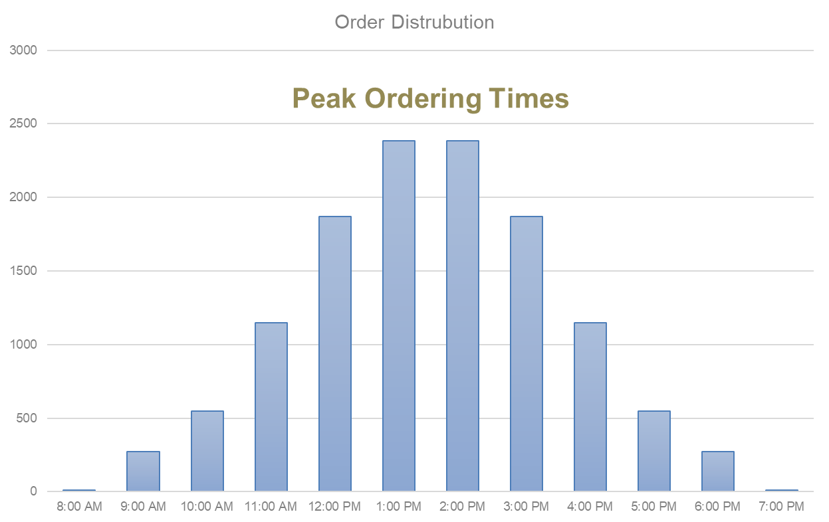

Figure 7: Orders throughout the day (Baltimore service area)

Orders rates throughout the day would also fluctuate and would not remain constant. A normal distribution was applied to the order rate gradually ramping up to a peak order rate of 2.4 thousand packages an hour in the middle of the day and then ramping back down till it tapers off at 8:00 PM. This is a simplification and does not consider seasonal shopping trends, this level of fidelity is planned for future iterations of the simulation with additional data coming from Amazon as model is further refined.

## Architectural views

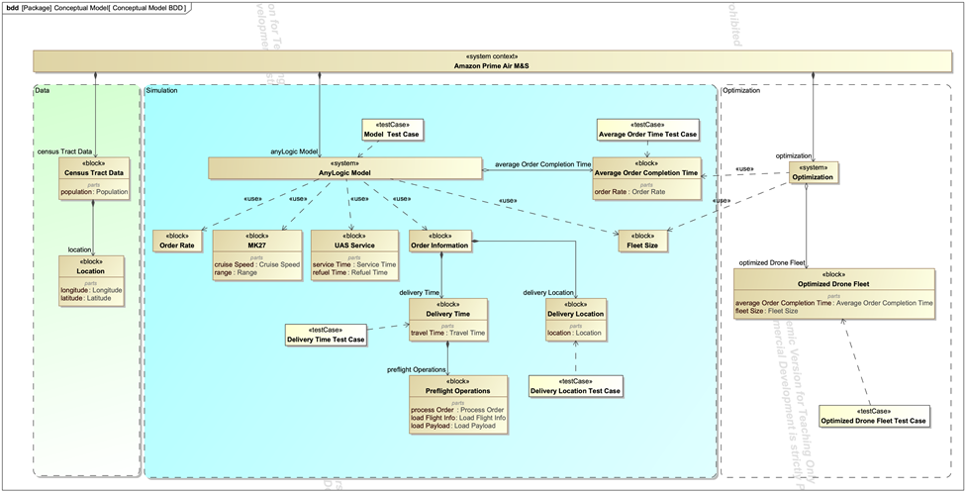The updated Amazon Prime Air Model & Simulation conceptual model is shown below in Figure 8. It is organized by inputted Data, the Simulation, and Optimization.

Figure 8: SCMS completed conceptual model

Data going into the model will include 2010 Census Tract Data which is used to determine population in the service area broken down by population in a specific Tract ID. The service area delivery locations will be located at the center of each tract and have an associated latitude and longitude values that will be inputted into the model.

Order information in the Anylogic model will consist of delivery location and associated time to complete the delivery. Delivery time will also include preflight operations. Preflight operations will consist of processing the order, loading flight info, and loading the payload. The AnyLogic Model will also take in inputs with the performance specifications of the MK27 UAS to ensure the model representation of the drone performs as it will in operations, with the nominal operational velocity and range restrictions. As Amazon rolls out the new delivery option, there will be a rate of adoption as the customer base begins to familiarize itself with the service. The order rate will be one key variable as it will be scaled for various adoption rates to emulate the growing percentage of customers utilizing the service.

Optimization will take the varying drone fleet sizes and run through the simulation through many iterations till the optimal drone fleet is determined. For the initial release of the model, the simulation will look to identify the minimum number of drones needed to fulfill a day’s (12-hour service window) with 95 percent of orders reaching the customers within the 30-minute delivery window. The initial model will be used as a baseline to assist sizing initial drone fleets for other markets.

## System Theoretic Views

Figure 9: SCMS activity diagram

From the conceptual model the simulation is further refined to highlight the individual functions it will need to perform, shown in Figure 9 above. Each function is identified, the inputs and outputs are allocated to the functions. The functions are then modeled to show the flow through the simulation and the iterations that it must go through to optimize the drone fleet size. The activity diagram was used to identify requirement satisfaction as part of the intrinsic V&V process SCMS followed.

# Data Collection

For modeling the behavior of Prime Air service and the MK27 drone, the information was collected from Amazon through their outlined CONOPs in their petition to the FAA [1]. The data from the CONOPs has already been outlined in previous sections on the flight pattern of the MK27 drone (Figure 4), and specifications of the MK27 drone (Figure 5 and Table 1).

For developing the scope of the problem, it decided to investigate the Baltimore Metropolitan Area. The focus was centered around the Baltimore Amazon Fulfillment Center in Baltimore City as the central drone hub.

## Population and Location

From the Amazon Prime Air concept of operations, the service area was sized to be 7.5 nautical mile radius surrounding the Amazon Fulfillment Center including areas in Baltimore City, Baltimore County, and Anne Arundel County. When looking into the service area, it was determined orders rates would be based on population density, with higher density areas having a higher probability to make an order. Population data was collected from the United States Census Bureau. The data was collected in the form of census tracts, small, relatively permanent geographic entities within counties delineated by the Census Bureau, shown below in Figure 10. Each tract was identified by a unique identification number. Each tract is designated with information on the demographic of the area. For this model population data was solely used to determine the probability of ordering, but in future iterations additional data will be incorporated to simulate the ordering behavior of the service area more accurately. The census tract latitude and longitudes we extracted from census map shape files and then merged with the population data. From there, an excel spreadsheet was used to generate a random set of census tracts based on population density. These 12,000 data points were imported into the AnyLogic model and used as our sample population data set.

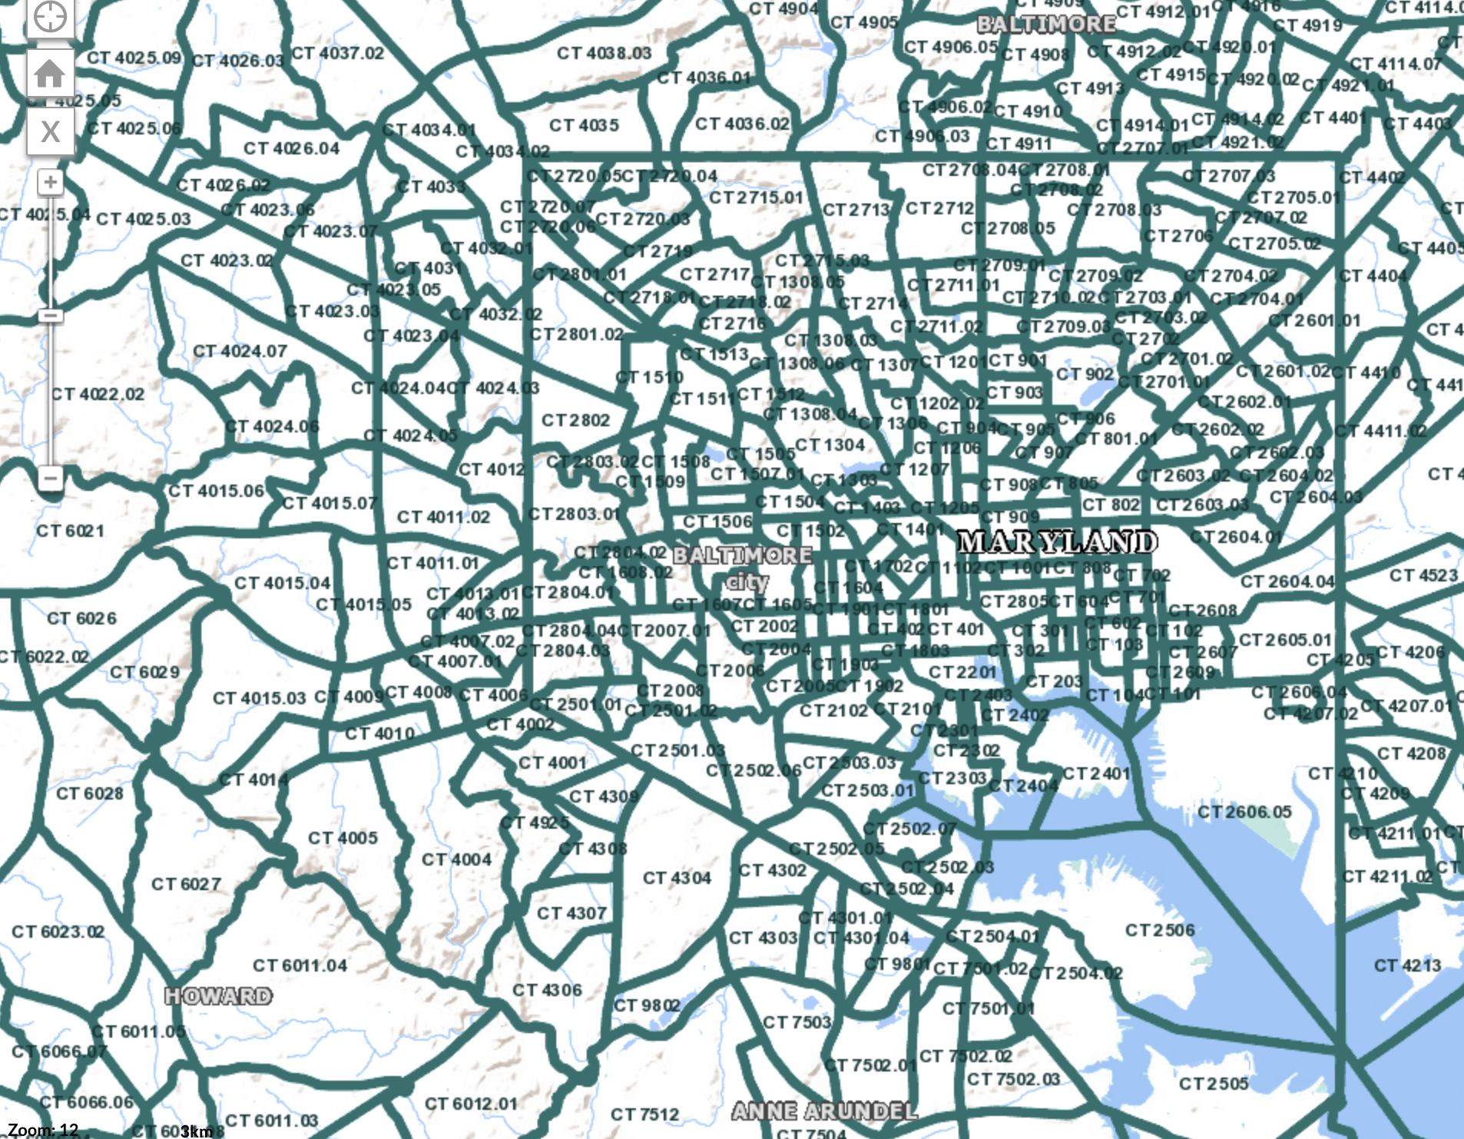

Figure 10: Baltimore area census tracts

# Verification & Validation

Verification and Validation was done throughout the development of SCMS from the development of the conceptual model to the coding of the simulation, to verification of the simulation. As part of the V&V efforts more work will need to be done to determine the fidelity of the model through comparisons with actual representative data. The V&V process outlined here provides confidence in the ability of the model to accurately demonstrate the system behavior as it pertains to order delivery of a drone delivery system servicing the Baltimore area.

## Verification & Validation Plan

In generating the conceptual model for SCMS an intrinsic V&V plan was generated from processes developed at Sandia National Laboratories by Witkowski [4]. Slightly modified for use on SCMS, the process is as shown below in Figure 11.

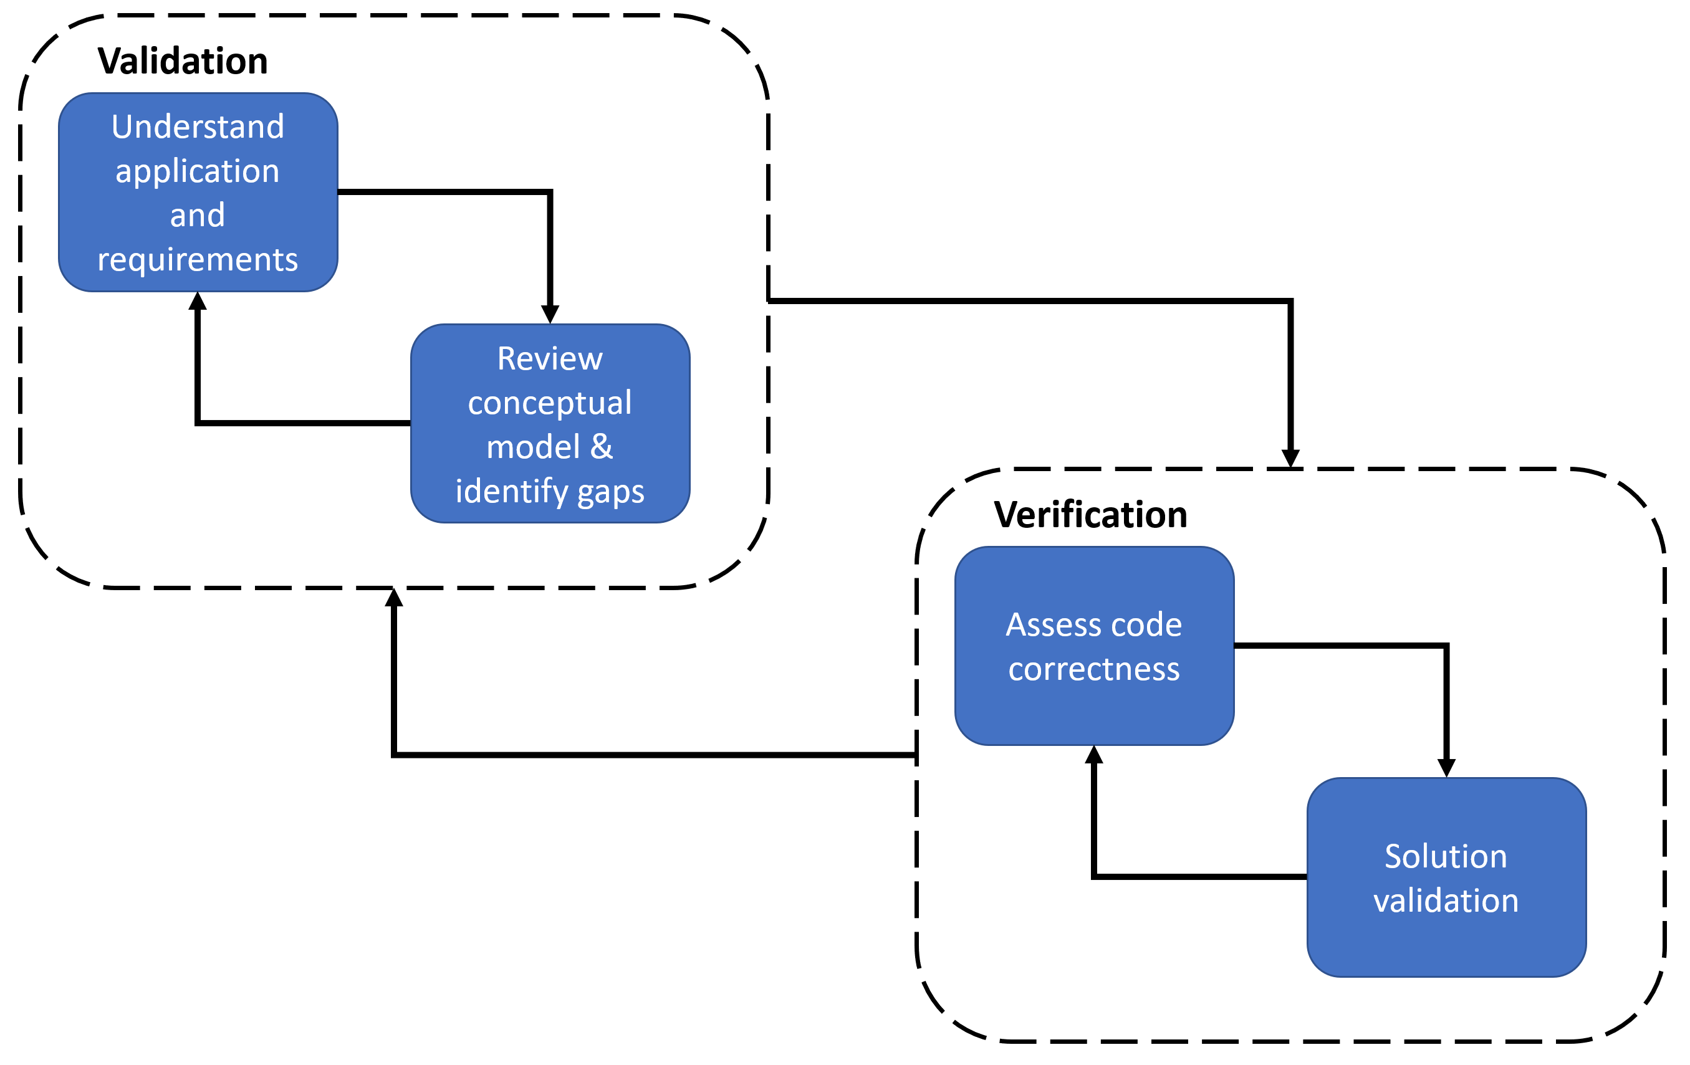

Figure 11: SCMS Intrinsic Verification & Validation flow

Figure 11 can be translated into the list below, that encompasses the validation and verification cycle that was done during the development of the conceptual model and simulation.

1. Validation
   1. Understand application and requirements.
      1. Review problem statement and requirements.
   2. Review conceptual model & identify gaps.
      1. Compare to existing models and identify risk.
2. Verification
   1. Assess code correctness.
      1. Verify code consistent behavior.
   2. Solution Validation.
      1. Compare to real world data.

As an iterative process, when validation is complete by running through steps a & b, the generated conceptual model can be translated to code. This starts the verification cycle. When the results are compared with real world data the code will be changed to accommodate the results, and if necessary, the conceptual model will be adapted for greater accuracy.

## Model Validation

To determine the validity of the model, the problem statement and requirements must be considered. From the problem statement:

What number of drones will sufficiently deliver packages within a 7.5 nm radius around the Amazon Baltimore fulfillment center in a 30-minute delivery window?

The output of interest is the number of orders that will be received on time for a given drone fleet size input. In this way it is a sizing problem, that seeks to determine the adequate fleet size to deliver a representative number of packages to a service area. Requirements SCMS-002 & SCMS-003 encompass these requirements for outputs and inputs.

The activity diagram shown in Figure 9 was checked to determine completion per the associated requirements in Table 2 to develop the requirements validation table shown below in Table 3. This created an assurance that the requirements were fulfilled per the conceptual model.

Table 3: Requirement validation

Finally, the assumptions for orders and delivery phase durations were compiled to create the Table 4 and Table 5 below. The flow and logic were built upon previous studies by Sudbury & Hutchinson [2] and Baggio [5].

Table 4: Order assumptions

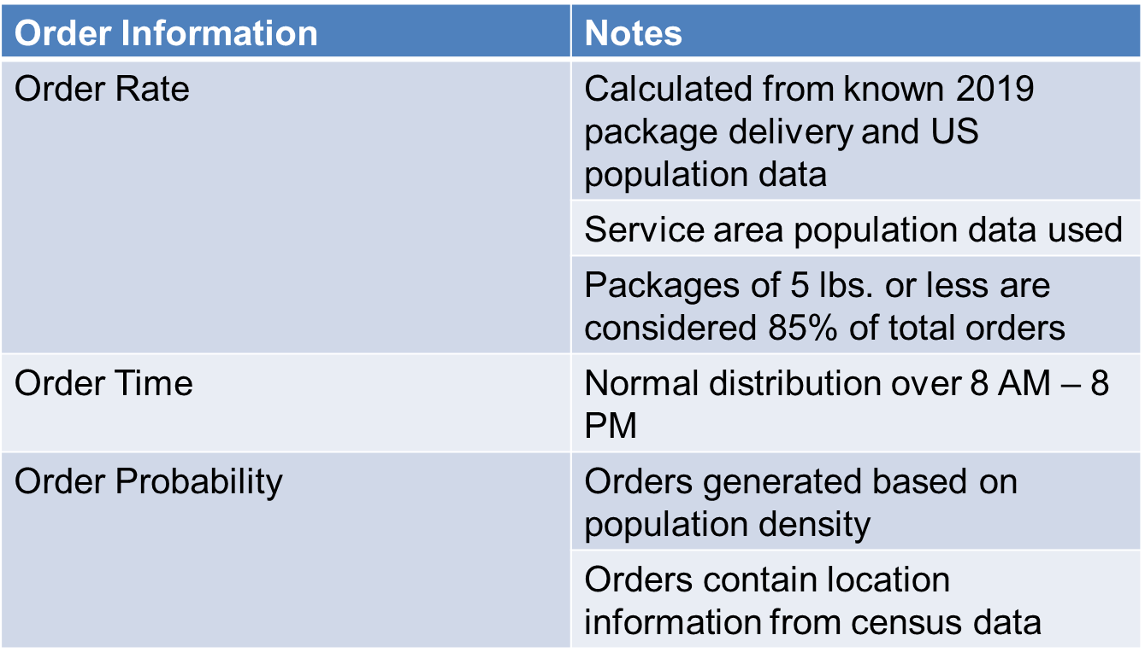

When reviewing order data, daily rate was generated from calculations based on national averages applied to the representative population in the service area. The daily order rate was then used to create a normal distribution to mirror the order patterns of people throughout the day. From that random orders were generated using population density to weight the probability so that more orders would come from more populous area.

Table 5: Drone delivery assumptions

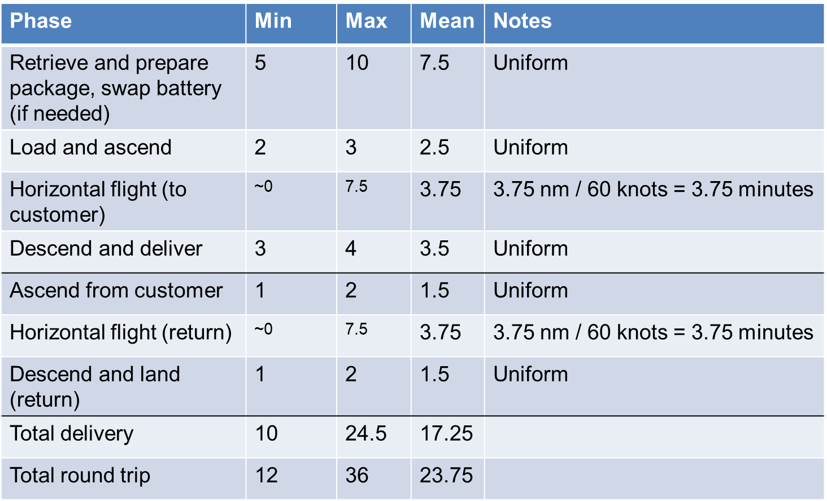

The flight and packing cycle of the drone listed in Table 5 followed those generated in a study by Sudbury & Hutchinson [2]. Randomness was incorporated to the delivery cycle by having the packing, load and ascend, descend & deliver, re-ascend, and descend & land phases draw time values from a bounded uniform distribution. In either the best or worst case, delivery time was well within the required 30-minute window.

The logic of the model follows that of previous studies by Sudbury & Hutchinson [2] and Baggio [5] as well as the Amazon Air CONOPs as shown in Figure 4. Being representative of the conceptual model, as well as tied to the requirements and problem statement the actual coding of the simulation could begin, leading to verification phase.

## Model Verification

When coded, the simulation needed to mirror the logic of the conceptual model. To ensure the logic was consistent, overload scenarios were run to test the limits of the simulations. In doing so modifications to the code were made to ensure the simulation and conceptual model were in lock step.

First the model was given a 10,000 orders/hour input which generated order queues, as each customer agent was unable to order while waiting for an order. To remedy this, the number of customer agents was increased to 12,000 to be roughly equivalent to total daily orders. In this way there would never be a queue to generate orders and orders would come in as intended hour after hour.

When the number of customer agents was increased, it created a need for the order rate to be transformed to be understood by AnyLogic. Using a transformation function for the intended number of orders, and considering the exponential rate used in the state diagram in AnyLogic, a linear transformation was made to generate the intended orders per time.

The last issue discovered and resolved was that there was no function to change order rate over time. This prevented a representative normal distribution of orders to be input. The solution for this ended up being fairly elegant, as an additional transition for time was used to update order rate after a set time to change order rate. This allowed for the rate to properly update to include the normal order distribution throughout the day.

Assured that the conceptual model was correctly answering the problem statement, the requirements were met, and the simulation was properly following the logic of the conceptual model experiments could not be run. Yet for full validation of the simulation small scale experiments would be needed to verify and validate elements of the model like the drone loading times, order distributions, etc. however the general behavior of a drone delivery system in Baltimore could be studied.

# Simulation Implementation

SCMS was coded in AnyLogic, being built off the conceptual model developed the problem statement and meet the stated requirements. For the simulation much of the logic for order and drone process flow was built on the work of Baggio in his development of a delivery fleet optimization [5]. Much of the process was modified to correctly model drone loading, ascending, etc. but it was built off the original logic used to model truck delivery to various airports in the Chicago area. The excel method of weighted probability was generated through locally developed logic by the SCMS team along with the customer state chart for order generation through.

## Optimization

The goal of SCMS was to determine the minimum number of drones to deliver orders. In that vein the model was optimized for specific parameter inputs as shown in Figure 12. Multiple simulations were run through a simulated 12-hour span to recreate daily orders to generate minimized results for drone size based on varying the delivery window, adoption rate, and on-time percentage. In using AnyLogic built in optimization functions were available as part of the software, allowing for results to be optimized for minimized fleet sizes through a simple set up of an optimization simulation. The experiments run in AnyLogic would make use of the optimization feature to generate minimized fleet results for a given input.

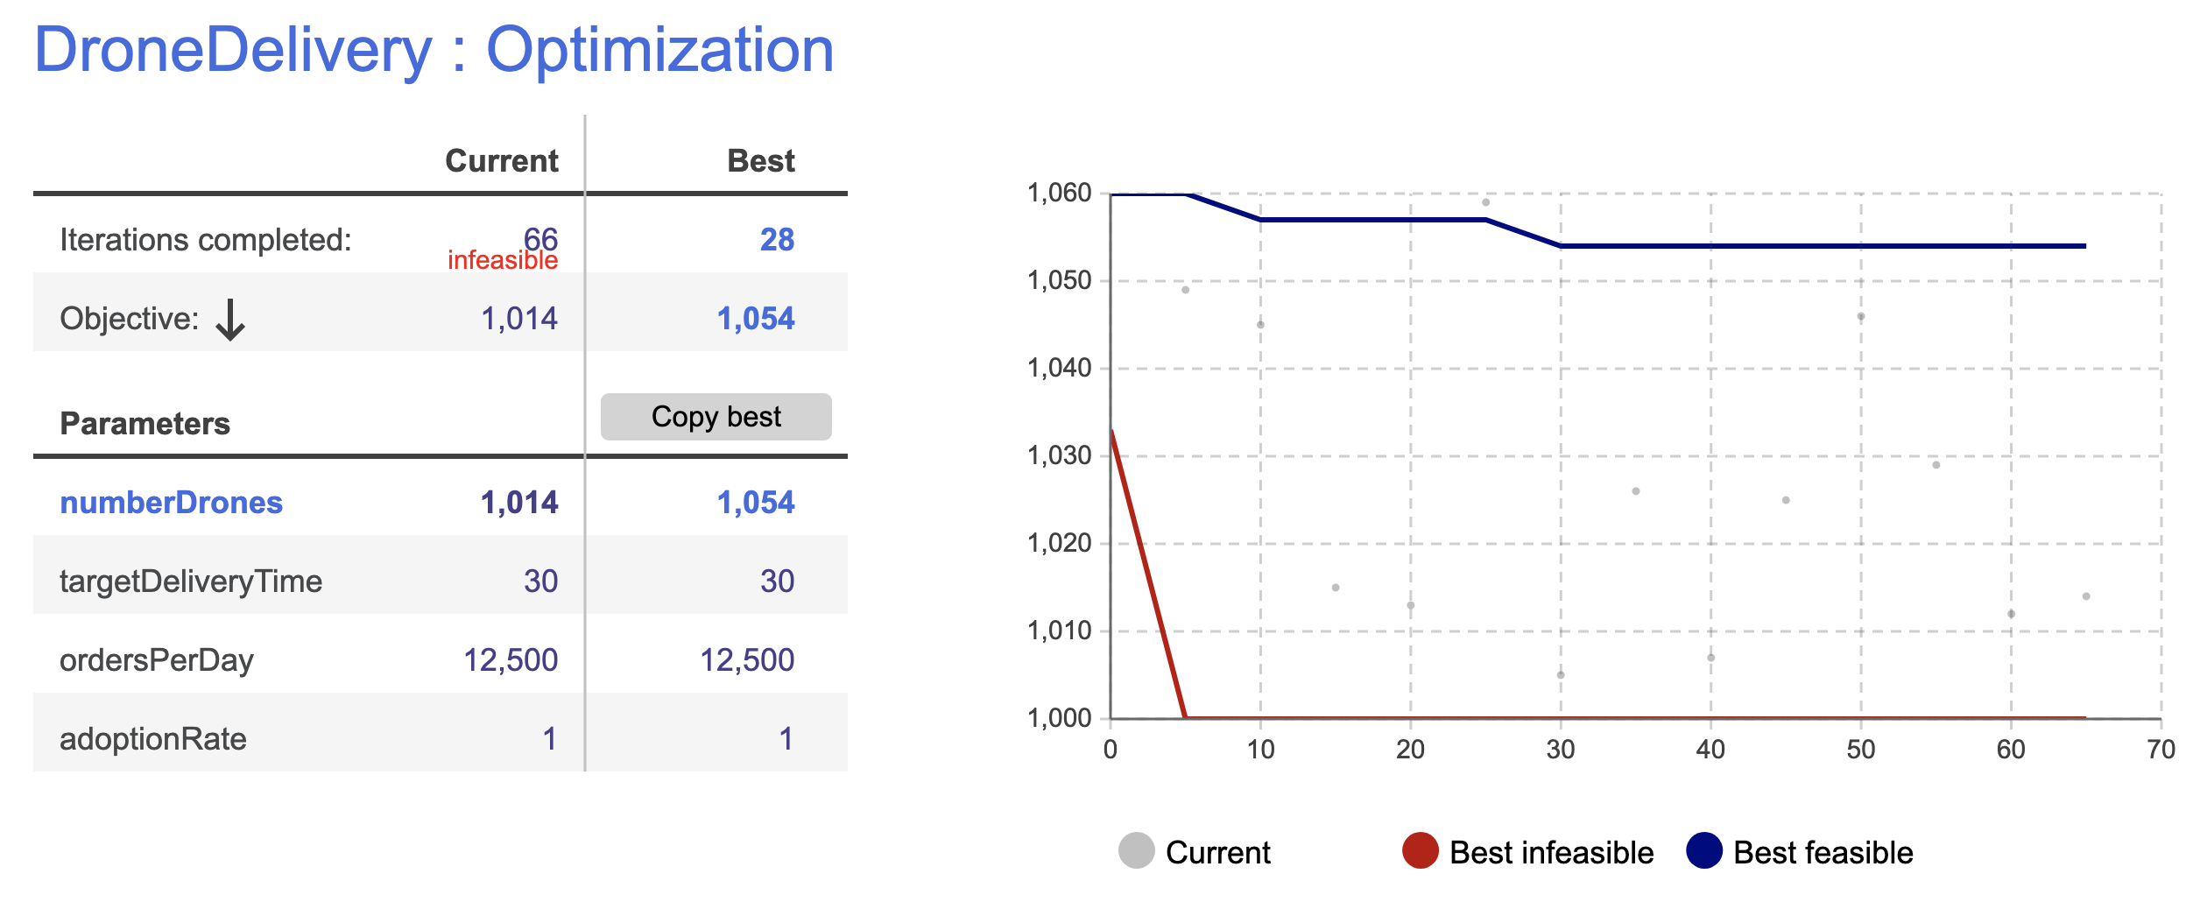

Figure 12: AnyLogic simulation optimization

# Simulation Model/Simulation Program

SCMS was entirely modeled in AnyLogic, though the random order generation was completed in excel. Models were then run through optimizations to generate results for the problem statement and the listed experiments. Assumptions were made to constraint the simulation, though the assumptions drew from previous models such as the study by Sudbury & Hutchinson on drone delivery in Chattanooga [2]. Logic for the process flow was modified from the delivery optimization performed by Baggio [5].

## Order Location

Census data contained tract numbers with population and latitude and longitude data. Using a distance function, the distance from the delivery center was determined and recorded which allowed only tracts within the 7.5 NM service area to be considered. Based on the population of the tract a weight was calculated based on the formula below that considers tract population and total population. For practical use with a random number generator, the result was rounded to the nearest integer after being multiplied by 1000.

$$Weight=Round(\frac{Tract Population}{Total Population}*1000)$$

The weight was then used to determine the associated probability by associating numbers to the tract that would be used to call the latitude and longitude data. As seen below in Table 6 associated weight accounted for with numbers 1-2 being assigned to tract 420800 due to the tract having a weight of 2 due to a population of 1706. Similar calculations were used to associate further numbers to all 225 tracts.

Table 6: Tract Data Example



After the data was compiled for the tracts and the weights were used to assign numbers for a random number generator, the Table 7 below was created. Random numbers were generated that were then used to call data from tracts related to their population. Associated latitude, longitude, and distance data was used to generate order lists. A representative number of orders were generated for the daily average orders that would be simulated.

Table 7: Probability Table



The generated orders were then used in the order agent to link to customer agents, as shown in Figure 13 below. The customer agent would then generate an order for the process flow of drone delivery.

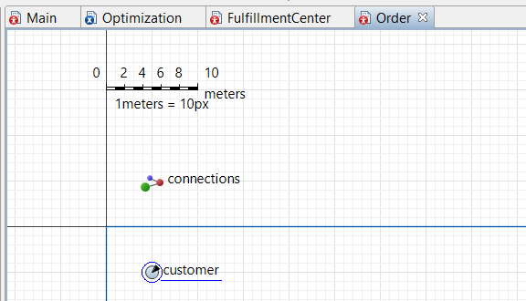

Figure 13: Order agent

## Customer Order Logic

With orders being generated through weighted probability in excel, the customer agent would then place the order for their assigned location. The customer state chart, shown below in Figure 14 describes the actions of the customer agent throughout the simulation.

The customer begins in a browsing state with two transitions flowing out form this state. An initial order rate is used in the rate transition to shift to a waitingDelivery state where an order will be sent to the fulfillment center agent, whose process flow will be described later. The second transition is a timer transition set to 5-minute intervals which triggers an order rate change. This allows for the order rate for each customer to change over the day to reflect increases in orders for peak order times.

Once the state changes to the waitingDelivery state two transitions exist moving out of the state again. The first transition is a message transition for order delivery, and transitions back to a browsing state. The second transition is a timer transition set to the delivery window time sending the customer to a late state.

From the late state, only a message transition exists to move back to the browsing state. Once back in the browsing state the process begins again where order rate is varied by the timer transition and orders are generated through the rate transition.

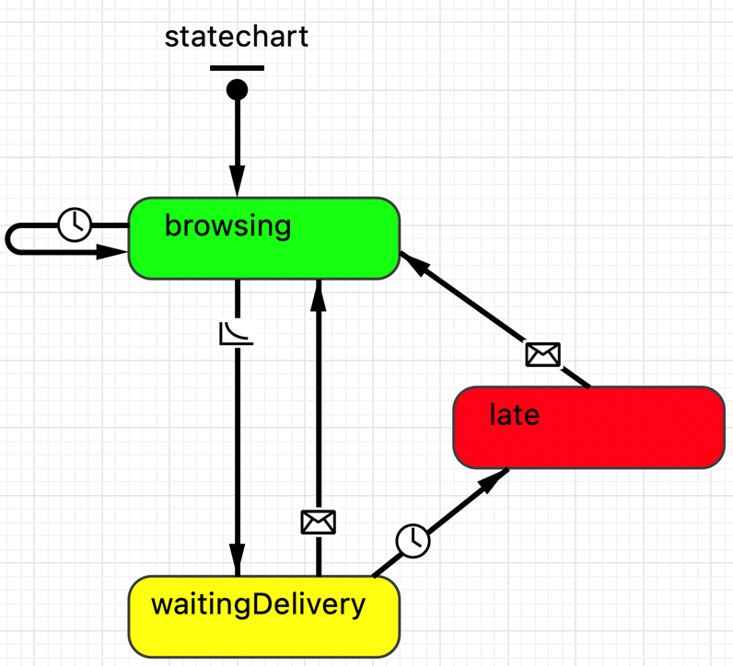

Figure 14: Customer state chart

## Drone and Order Process Flow

The drone and order process flow exists in the fulfillment center agent and is visually shown below in Figure 15. Orders are generated from the customer agent state chart which then transfer to the fulfillment center agent to start the delivery process flow. An order enters the process flow and begin the delivery timer before moving to the seize block.

The seize block draws the drone resource from the available fleet, and the drone delivery process begins. The drone moves through delay blocks for preparing to ship, loading & ascending, traveling to the customer, and descending for delivery before moving to a release block to return to the fulfillment center. Each delay block has a number generated through uniform distribution that determines the time spent in each delay block. The delivery timer then stops, and the order progresses to the delivered sink.

After the release block the drone moves through a similar process flow for return to the fulfillment center. There are ascend, return to fulfillment center, and descend/land delay blocks that control the path of the drone on its return. The delay blocks have a number generated through uniform distribution to determine time in the delay block like the delivery trip. The drone then hits the resource task end and is available for another delivery. Data was then output on the simulation run, as described in the Presentation section.

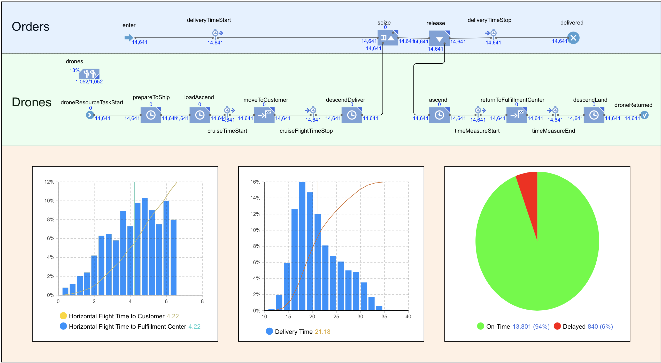

Figure 15: Resource Flow Chart

## Result Validation

The results generated through SCMS are lower fidelity due to the numerous assumptions and simplifications made. Specifically, the use of randomized time ranges based on the Chattanooga study by Sudbury & Hutchinson [2] provide a strong basis for the SCMS results. Shown in Figure 16 & Figure 17 below simulation results were consistent with the conceptual model, even for overloaded scenarios with 1,000,000 orders/day and 80,000 drones in the fleet. Yet concrete time data can be generated for comparison and updating of the code and conceptual model as defined in the SCMS V&V process. Through the SCMS V&V process, both the conceptual model and simulation were checked for concurrency and completeness to the problem statement and requirements. As such there is high confidence that the behavior described by SCMS is representative of a drone delivery system. The specifics of delivery time and on-time percentage represent a lower fidelity estimation that could be made using the same model, but with time standards derived from the real-world application of the system or representative components of the system.

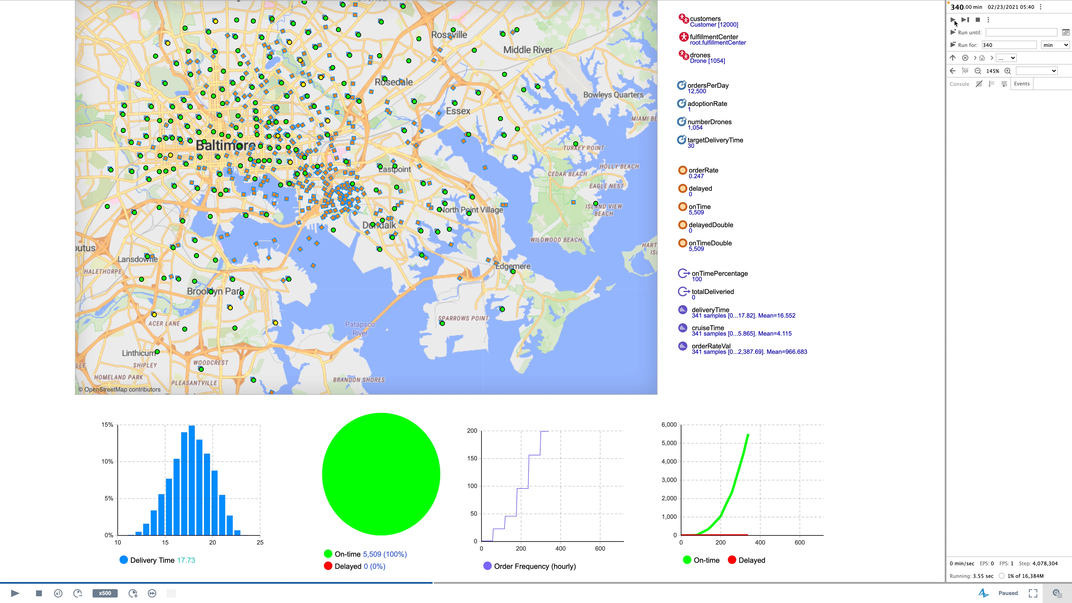

Figure 16: Primary Experiment Run

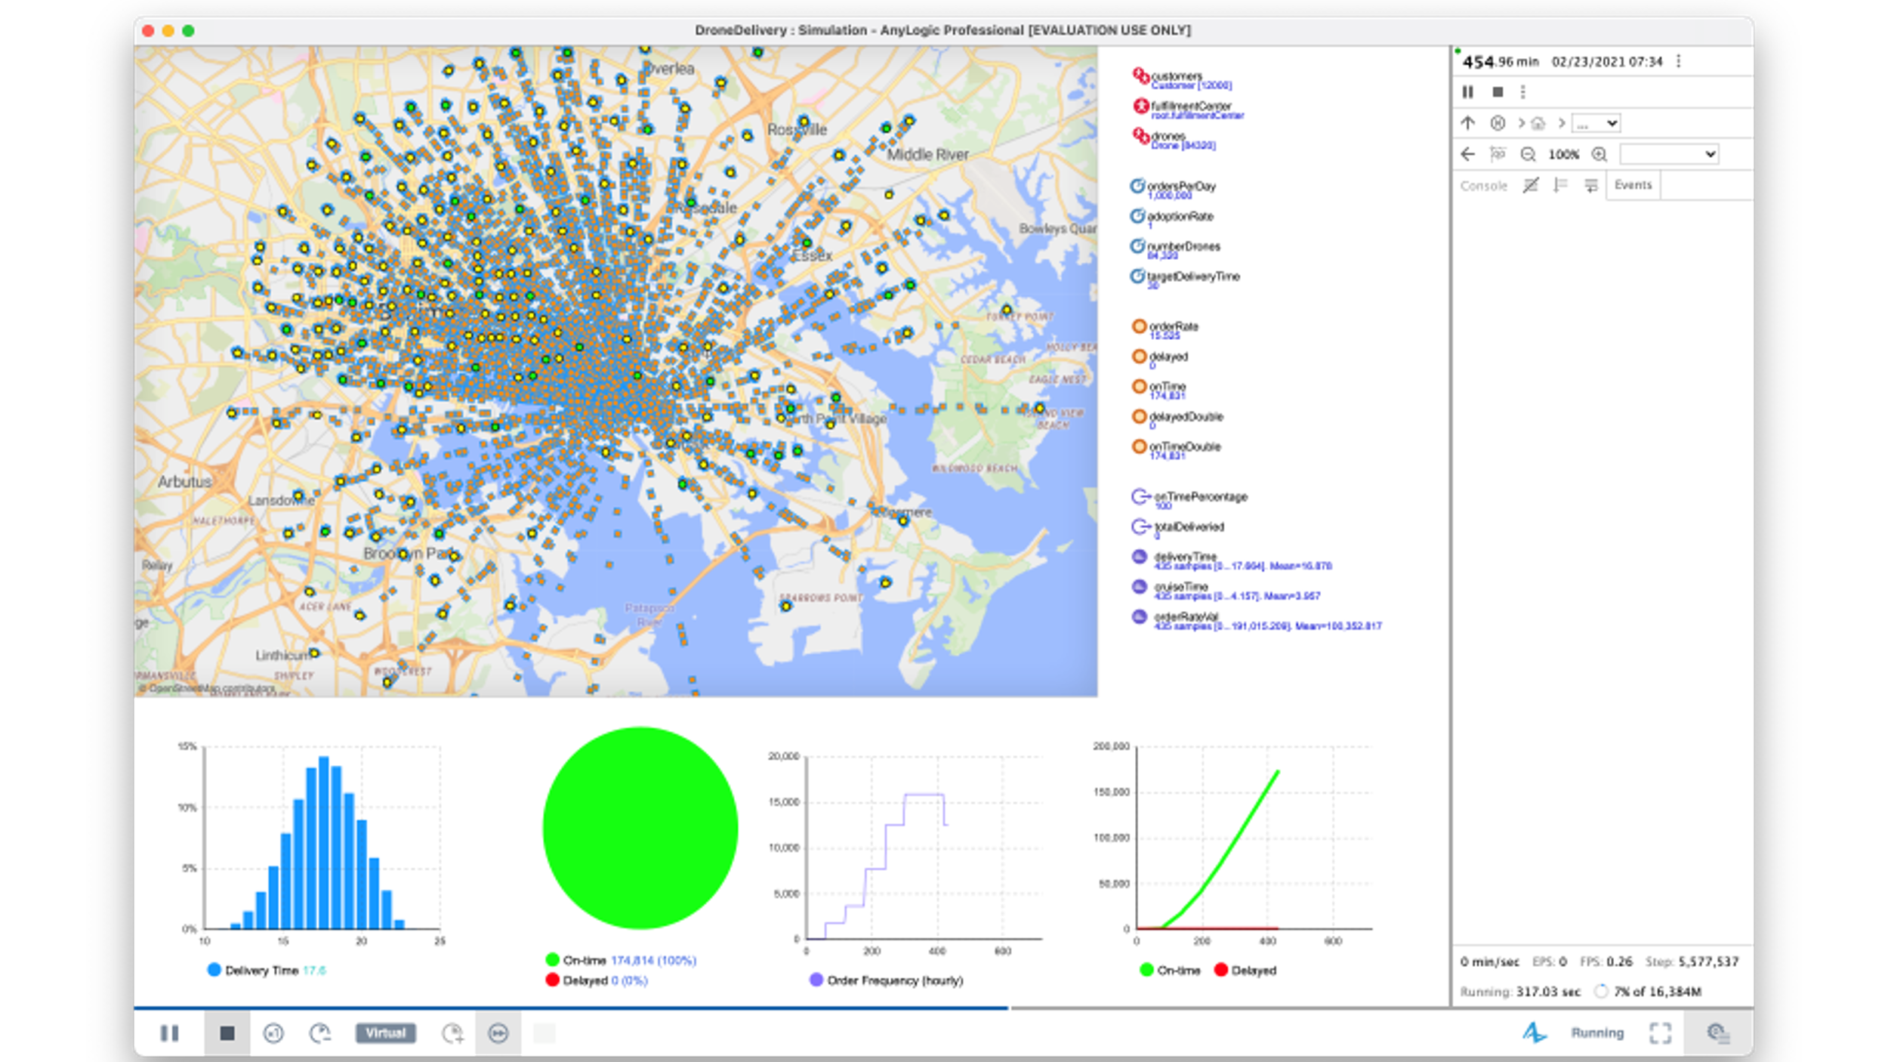

Figure 17: Overload Scenario Run

# Presentation

Input data for the simulation was generated through the assumptions, data collection, and calculations described earlier. Of interest would be the orders per day [ordersPerDay], adoption rate [adoptionRate], drone fleet size [numberDrones], and delivery window [targetDeliveryTime]. Each parameter was edited in the Main window for single simulation runs.

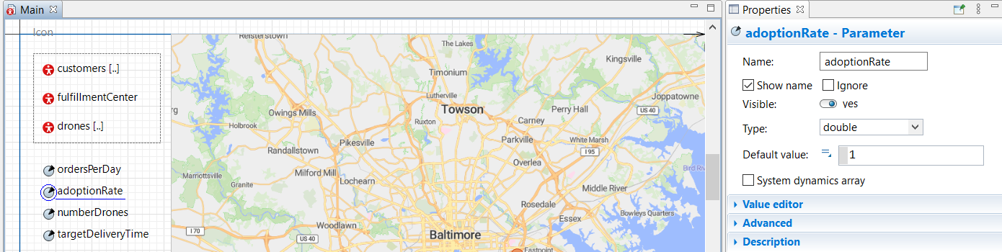

Figure 18: Simulation data inputs

Once running, a 2-D representative map of Baltimore was used with overlaid dots representing the census tract centroid, as shown below in Figure 19. Each dot would change color from green to yellow when waiting on an order, then changing back to green if delivered in time or red if late. If late the dot would only return to green once the package was delivered. Drones were represented as blue dots traveling from the drone hub of the Baltimore Amazon Fulfillment Center to each location as they deliver their order.

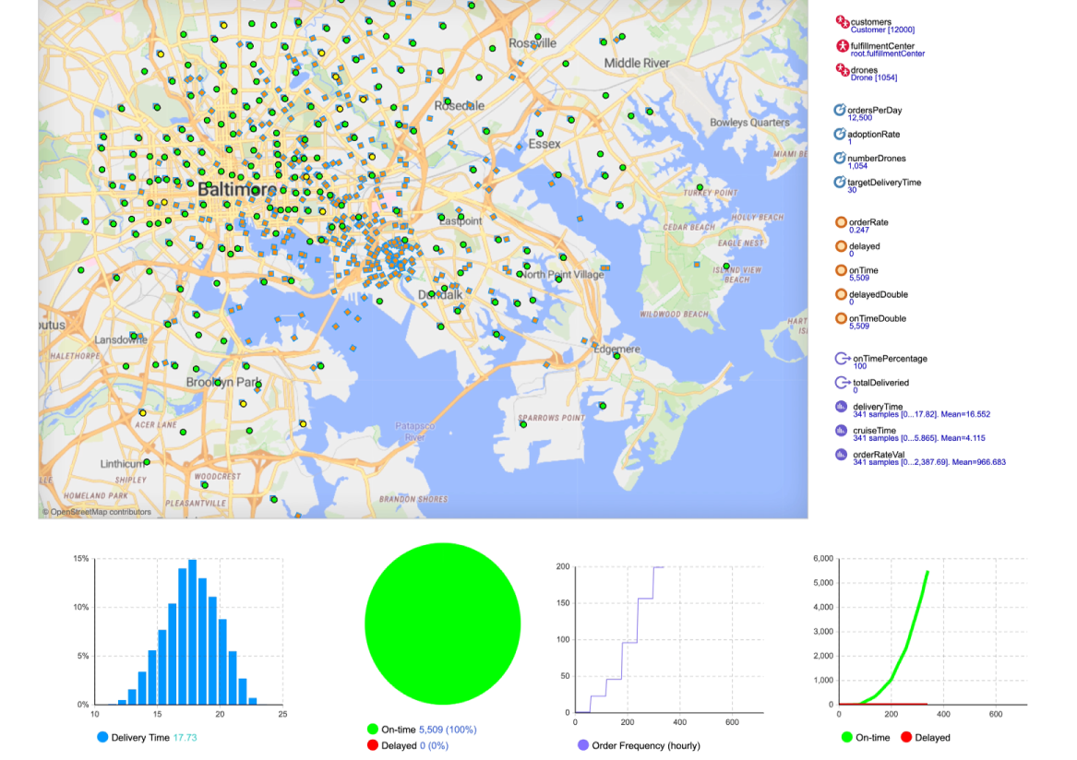

Figure 19: Simulation run

Below the Baltimore area map, a histogram of delivery time showing average delivery time is given. Additionally, a pie chart is used to show the proportion of orders on time and late. Graphs for order rate through the day are also provided along with a graph for total orders on time, and total delayed orders. The graph for on time and delayed orders was used to show at what point orders became delayed and could be tied to the order frequency at that time.

# Experiments

Three experiments were run to vary adoption rate, on-time percentage, and delivery window. Each result presented was the result of running the simulation through 100 iterations to minimize drone fleet size for the given parameters. Optimizations were run without a random seed so that each model was deterministic to an extent.

## Experiment 1, Varied Adoption Rate

The initial experiment run was to vary the adoption rate of drone delivery to see how many drones would be needed when varying the percentage of total orders being delivered by drone. While ideally all packages that are eligible would be delivered through drone, the reality is that not everyone would be comfortable received drone delivered packages, or weather conditions may prevent drone delivery. For those reason varying adoption rate was varied to determine how the implementation of drone delivery may need to ramp up as adoption of the service expands. The results were collected in Table 8 showing that when the adoption rate was varied proportionally the number of drones needed similarly dropped. Adoption rate was dropped from 1 to .1 as a proportion of total number of packages to be delivered by drone. Each adoption rate had an optimization to minimize the required number of drones run for 100 iterations. Adoption rate was the only variable changed, and the on-time percentage was required to remain at 95% along with a 30-minute delivery window.

Table 8: Adoption rate vs. number of drones



Figure 20 below shows the graphical relationship between adoption rate and the required number of drones to hit a 95% on-time percentage. Graphically it is very easy to see the linear relationship between drone delivery and adoption rate. Since the relationship is linear it is possible to generate fleet sizes that would meet the system requirements for delivery by simply taking the expected adoption rate and applying the linear relationship shown in Figure 20. Of course, to get the formula, multiple optimizations would need to be run for varying adoption rate, with the location of interest being input into SCMS, yet the clear linear relationship would similarly exist in other locations.

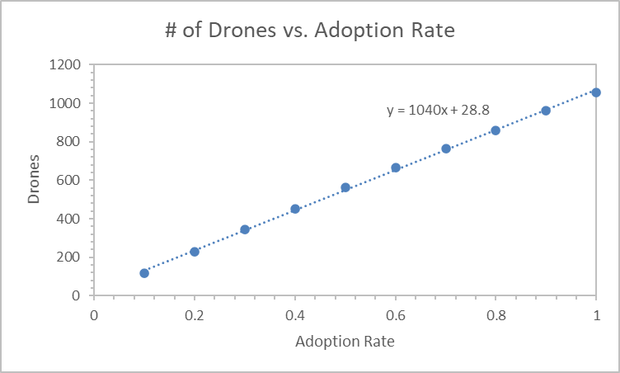

Figure 20: Adoption rate vs. number of drones (graph)

## Experiment 2, Varied On-time Percentage

After varying the adoption rate, on-time percentage was varied to determine the impact that would have on required fleet size. Based on the results of experiment 1 with varying adoption rate times, it was assumed that there would be a similar linear relationship between fleet size and the on-time percentage. Though there was no financial information included in SCMS, areas where the required number of drones would be less were of particular interest for cost saving measures. Each varied on-time percentage was optimized for the minimum number of drones to hit the same daily order rate, 30-minute delivery window and 100% adoption rate for 100 iterations. As shown in Table 9 as on-time percentage was reduced, the required number of drones fell as well. However, as the percentage fell, the number of drones fell much slower as shown in the percentage of fleet size column where the required fleet size was given as a percentage of the number of drones required to hit 100% on-time percentage.

Table 9: Number of drones vs. on-time percentage



Due to the small change in drone size required to achieve higher on-time percentages the relationship was shown to be exponential, as shown graphically in Figure 21. A peculiar result was the constant number of drones (955) required to have an on-time percentage of 60% and lower.

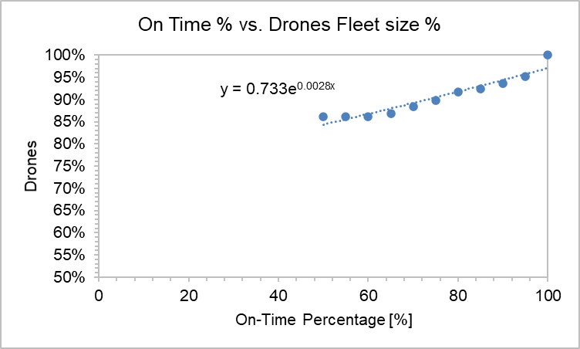

Figure 21: Number of drones vs. on-time percentage (graph)

A single simulation was run to find the on-time percentage for the given 955 drones, shown in Figure 22 below, and it was found that the true on-time percentage was 66%. The optimization was providing the 60% result due to the on-time percentage output being updated for the entirety of the simulation. As such the on-time percentage would dip hover around 60% and the 955 drones would become an acceptable result.

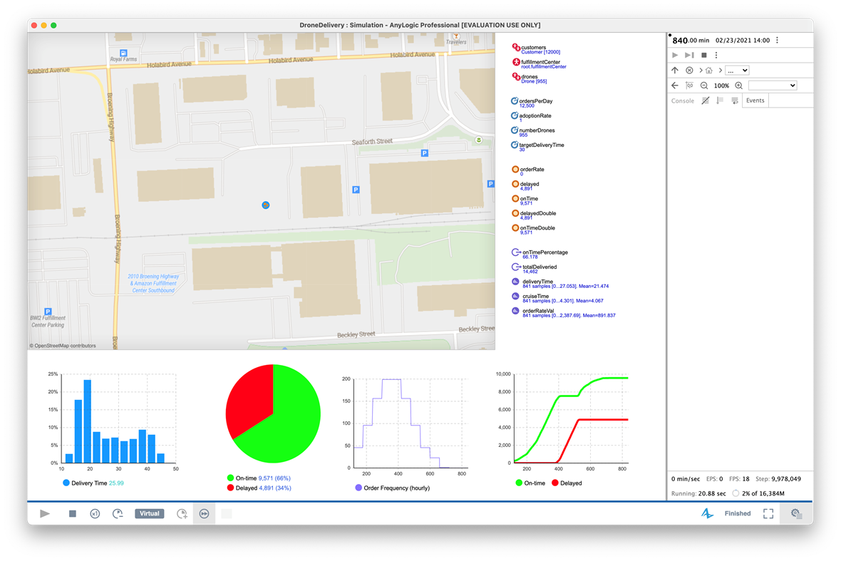

Figure 22: Simulation run for 955 drones

Additionally, as seen in Figure 22 most late deliveries would occur as a result of the peak order times. This confirmed an initial hypothesis of the team that peak delivery times would be the main sizing factor for drone fleet sizes.

## Experiment 3, Varied Delivery Window

As changing the on-time percentage showed how peak delivery times were the driving factor for fleet sizes, changes in delivery window was considered as well. Again, the inspiration for this experiment was to determine the decrease in drone fleet size that was associated with increased delivery window span. For each delivery window the on-time percentage was kept at 95%, and adoption rate was kept at 100% for 100 iterations to minimize the fleet size. As shown in Table 10 as delivery window increases the fleet size decreases, with a delivery window of 2 hours requiring nearly half the drones required for a 30-minute window.

Table 10: Delivery window vs. number of drones



Figure 23 below shows the graphical relationship between delivery window and drone fleet size which can be seen to be an exponential relationship. From the results of this experiment a new question was posed, which was what percentage of the drone fleet was being used at throughout the day? While the delivery window was expanded, it allowed for a higher utilization rate of drones throughout the day. Which while increasing the load and wear down of each drone, would reduce the initial financial cost required to stand up drone delivery operations could increase the maintenance costs associated with the fleet.

Figure 23: Delivery window vs. number of drones (graph)

As part of this experiment an attempt was made to determine the number of drones needed for a 15-minute delivery window. Due to the nature of drone delivery outlined in Table 5 no feasible solutions existed within reason. As delivery times varied from 10 to 24 minutes with a mean of 17 minutes an extraordinary number of drones would be required to meet 15-minute delivery windows per the simulation. This result indicates that for smaller delivery windows fundamental changes need to be made that would allow for faster loading and launching or multiple drone hubs throughout a service area to reduce flight times.

# Results and Conclusions

In tackling the initial objective of SCMS, it was determined through simulation and optimization that 1054 drones were required to achieve a 95% on-time delivery percentage within a 7.5 nautical mile radius of a Baltimore Amazon Fulfillment Center. This is for a delivery window of 30 minutes and an adoption rate of 1.

When running the simulation 96% of total packages were delivered on-time, which adheres to our goal of 95% on-time delivery. It was also seen that average delivery time is approximately 19 minutes.

As a result of the experiments run through the simulation some recommendations were generated for the implementation of drone delivery systems. As was seen in experiment 1, adoption rate was more impactful for the required drone fleet size than changing the required on-time percentage. As such it would be of more importance to determine the intended adoption rate for drone delivery in each area than adhering to delivery window requirements in sizing the fleet.

From experiment 2, it was determined that peak order rate was the driving factor for drone fleet size. Not unexpected peak demand would drive the requirements for fleet size as the system is stressed to accommodate peak orders. This emphasizes the importance of understanding the peak demand for system sizing and vice versa, so knowing what a respective fleet size can accommodate for peak demand.

Finally, from experiment 3, it was shown that increasing delivery window lowered the required fleet size exponentially. Allowing for more time to process and transport an order allowed for higher utilization rates for the drone fleet which would accommodate the same orders, but with larger stress on individual drones.

## Recommendations

Looking to next steps following the initial SCMS study there are actions that must be completed to generate higher fidelity models. It is recommended that small scale experiments be used to generate higher fidelity time standards for a drone delivery system. Representative tests should be done to determine load times, drone flight characteristics for flight times, delivery spans to model the delivery flow more accurately.

Additional tests should be run on the reliability of the MK27 drone so that longer span simulations can be run to accommodate for drone maintenance and breakdown. Longer experiments would also include peak days so representative order data must be generated and provided to SCMS.

Data should also be provided on the cost of MK27 drones so that financial data can be generated for the drone fleet. Operational costs should also be included so lifespan costs can be generated for individual drones and overall fleets.

## Future Experiments

After running the initial three experiments many new ideas were generated for additional experiments. One experiment building off the results of experiment 3 would be to determine the utilization rate of a drone fleet throughout the day. This naturally flows into the addition of financial information to SCMS to optimize fleet sizes for cost.

The initial experiments should also be re-run to include random seeds so that the models become less deterministic and more representative of real-life processes.

Another experiment would be to integrate cost information into the model to make financial predictions and decisions. There is potential that drones could be both faster and cheaper than current delivery costs. By incorporating cost into the model along with the number of operators needed, the average cost for a single delivery can be determined. From there, the percent return on investment in drone infrastructure could be determined.

As more data becomes available with an increase in delivery landing pads/zones for drones, better battery life and faster recharging, increasing fleet sizes, etc. more data can be provided to the model for future optimization.

# References

|  |  |
| --- | --- |
| [1] | S. Cassidy, *RE: Amazon Prime Air – Petition for Exemption Under 49 U.S.C. § 44807 and 14 C.F.R.,* Washingtion, DC, 2019. |
| [2] | A. W. Sudbury and E. B. Hutchinson, "A COST ANALYSIS OF AMAZON PRIME AIR," *JOURNAL FOR ECONOMIC EDUCATORS,,* pp. 1-12, 2016. |
| [3] | D. Davis, "Amazon is the fourth-largest US delivery service and growing fast," 26 May 2020. [Online]. Available: https://www.digitalcommerce360.com/2020/05/26/amazon-is-the-fourth%E2%80%91largest-us-delivery-service-and-growing-fast/. |
| [4] | W. Witkowski, *Intrinsic Verification & Validation/UQ:,* Sandia National Laboratories, 2013. |
| [5] | T. Baggio, "Delivery Fleet Optimization with GIS Functionality Webinar," AnyLogic North America, LLC, Chicago, 2015. |